caLAB – cancer Laboratory Analysis Bench

Software Design Description

Release 1.0

Document Change Record
Version Number | Date | Description
1.0 | 09/06/06 | Initial document

TABLE OF CONTENTS
1. Introduction 1
1.1 PROJECT BACKGROUND 1
1.2 identification 1
1.3 Requirements 2
1.4 System Overview 3
1.5 Document Overview 4
1.6 Reference documents 4
2. System Architecture 6
2.1 SYSTEM Architecture OVERVIEW 6
2.1.1 User Client Software 7
2.1.2 Presentation Layer 7
2.1.3 Business Logic Layer 7
2.1.4 Persistence Layer 7
2.1.5 Server 8
2.2 SYSTEM Deployment OVERVIEW 8
3. Components 10
3.1 Domain MODEL 10
3.1.1 Base caLAB Object Model (calab-om) 10
3.1.2 Nanoparticle Object Model (nano-om) 12
3.2 daTA MODEL 19
3.2.1 caLAB Data Model (calab-om) 20
3.2.2 Nanoparticle Data Model (nano-om) 22
3.3 Presentation layer 24
3.4 FILE STRUCTURE 24
3.5 Common Security Module 25
Appendix A – acronym List 27

Introduction
The purpose of this document is to describe the design for the cancer Laboratory Analysis Bench (caLAB) Release 1.0.

PROJECT BACKGROUND
The caLAB effort is collaboration between the NCICB and the Nanotechnology Characterization Laboratory (NCL) facilitating the development of standards supporting nanotechnology in medicine. The NCL performs and standardizes the characterization of nanomaterials intended for cancer therapeutics and diagnostics. One of the goals of the collaboration is the establishment of nanoparticle characterization standards in support of data sharing with the Cancer Centers of Nanotechnology Excellence (CCNEs) and caBIG™ participants.

The caLAB 1.0 effort expands upon the caLAB .50 release which focused on capturing the NCL workflow and workflow artifacts. caLAB .50 features included:

- Sample Management – Accessioning samples (nanoparticles), creating aliquots, searching samples and aliquots
- Execute Workflow – Creating assay runs, assigning inputs (aliquots) and outputs (result files) to assay runs, searching workflow components for assay results
- File Upload – Uploading assay results
- Basic Security – User authentication via the NCI’s Common Security Module (CSM)
Release 1.0 features include:
- Annotate Nanoparticles – Annotating nanoparticles with characterizations, searching and retrieving nanoparticle characterizations
- Advanced Security – User authorization via the CSM, User management via the NCI’s User Provisioning Toolkit (UPT)
The design of Release 1.0 features involves the extension of the existing caLAB .50 web portal and generic laboratory object model (calab-om) with nanoparticle annotations and role-based security. In Release 1.0, these nanoparticle annotations are represented in a nanoparticle object model (nano-om) defining the composition of a nanoparticle, nanoparticle functions in biomedicine, and nanoparticle characterizations. In Release 1.0, nanoparticle characterizations include characterizations resulting from physical and in vitro nanoparticle assays only.

identification
The system identification information to which this document applies is as follows:
- Title: cancer Laboratory Analysis Bench
- Abbreviation: caLAB
- Version: 1.0
- Release Number: 1.0

Requirements
The following is a list of high-level functional and technical requirements for caLAB 1.0:
Req. # | Requirement
1.0 | The system shall provide advanced security
1.1 | The system shall provide support for role based authorization
1.1.1 | The system shall allow administrators to configure groups and group privileges (read only, read-write)
1.2 | The system shall leverage the NCICB Common Security Module (CSM)
1.3 | The system shall provide support for user management
1.4 | The system shall leverage the NCICB User Provisioning Toolkit (UPT)
2.0 | The system shall support submission and retrieval of nanoparticle annotations
2.1 | The system shall allow users to annotate and search nanoparticles based on the nanoparticle composition specific to each nanoparticle type
2.2 | The system shall allow users to annotate and search nanoparticles based on nanoparticle characterization
2.3 | The system shall provide support for physical characterizations
2.4 | The system shall provide support for in vitro characterizations
2.5 | The system shall allow authorized users to submit assay results (e.g. distribution graphs) and associate assay results with annotations (e.g. size distribution graph, z-avg. size, PDI)
2.6 | The system shall allow users to annotate and search nanoparticles based on nanoparticle function
2.7 | The system shall allow authorized users to specify the visibility of the report
2.8 | The system shall allow users to upload and retrieve nanoparticle reports
2.8.1 | The system shall allow users to associate reports with multiple nanoparticles
2.8.2 | The system shall allow users to set the visibility of the reports to pre-defined groups
3.0 | The system shall be engineered for caBIG compatibility
3.1 | The system shall leverage the caCORE SDK and associated components
3.2 | Concepts for supported objects/attributes shall be registered in the EVS
3.3 | The object model shall be loaded into the caDSR

Table 1-1: Requirements Matrix
These requirements are further expanded in the caLAB 1.0 Use Case Specification.

System Overview
The primary goals of the caLAB Release 1.0 effort are to:
- Provide for the efficient storage and retrieval of nanoparticle characterizations to expedite and validate the use of nanotechnology in medicine
- Develop and support an initial standard for representing nanoparticle characterizations to facilitate data sharing in a semantically interoperable fashion in the spirit of caBIG™
- Implement a system that facilitates data sharing in the nanotechnology community in a secure fashion

System Development
The caLAB 1.0 effort is being designed and developed in an iterative fashion. As such, it is intended that this document will be updated on a frequent basis during the elaboration phase of each iteration. caLAB 1.0 iterations within the release are defined below.
- Iteration 1: Security (Authorization using the CSM)
- Iteration 2: Nanoparticle Composition
- Iteration 3: Nanoparticle Characterizations (Physical and In Vitro)
- Iteration 4: Nanoparticle Function/Reports

Operations and Maintenance
caLAB 1.0 is being deployed and maintained at the Advanced Biomedical Computing Center (ABCC) in NCI Frederick for use at the NCL.

Key Stakeholders
Key stakeholders associated with the effort are defined as follows:

- Nanotechnology Characterization Laboratory (NCL) – End users of the caLAB system
- Cancer Centers of Nanotech Excellence (CCNEs) – Consumers of caLAB data
- Advanced Biomedical Computing Center (ABCC) – Provides caLAB operations and maintenance support
- National Cancer Institute Center for Bioinformatics (NCICB) – Provides development and metadata support

Document Overview
This document provides an overview of caLAB system design. It is intended to describe and capture the caLAB design decisions and is written as a reference for both the NCI customer and the NCI contractors/developers involved with the evolution of caLAB. This is a living document and will be updated to reflect the evolution of development, as well as future enhancements and upgrades.
The main sections of this document are listed and described below.
- Section 1. Introduction: provides a purpose statement, project background, requirements matrix, system overview, and document overview.

- Section 2. System Architecture: Describes an overview of the system, the conceptual and architectural design, interfaces, and the various environments that will be used throughout the development lifecycle.
- Section 3. Components: Identifies and describes each component broken down into its parts that are described in detail.

Reference documents
Document Name | Version | Location
CaLAB Scope Document | 1.4 | CVS Server: cbiocvs2; module: calab; Directory: docs
caLAB 1.0 Use Case Specification | 1.0 | CVS Server: cbiocvs2; Module: calab; Directory: docs
caLAB 1.0 Wire frames | 1.0 | CVS Server: cbiocvs2; module: calab; Directory: docs
caLAB 1.0 Security Configuration Document | 1.0 | caLAB 1.0 Security Configuration Document
caLAB 1.- Architecture Checklist | 1.0 | NCICB CM team
caCORE SDK and CSM | 1.1 | Refer caCORE Technical guide for the design document. ftp://ftp1.nci.nih.gov/pub/cacore/SDK/caCORE_SDK1.0.3_Programmers_Guide.pdf
caBIG Compatibility Guidelines | 2.0 | https://cabig.nci.nih.gov/guidelines_documentation/caBIGCompatGuideRev2_final.pdf

Table 1-2: Reference Documents

System Architecture

SYSTEM Architecture OVERVIEW
The caLAB architecture is based on an n-tier computing environment that assigns responsibilities to separate application layers. This fosters a loosely coupled and tightly cohesive architecture in which objects in each layer are focused on specific architectural responsibilities yet, cleanly integrate with the other layers.

The purpose of this section is to give an overview of the caLAB 1.0 architecture as background for the discussion of Release 1.0 changes in later sections. The following diagram shows the overall architecture of caLAB. An overview of each component is provided in the sections immediately following the diagram.

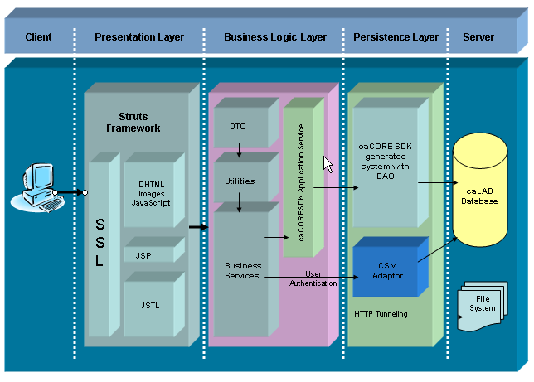
Figure 2-1: System Architecture

User Client Software
caLAB is a web-based application. Users (laboratories) access NCL through commonly available web browser software using the HTTPS protocol. JavaScript must be enabled in the browser.

Presentation Layer
The caLAB presentation layer is implemented as HTML and JavaScript. The use of JavaScript is limited to improving usability only.
Java Server Pages (JSPs) are used to generate dynamic HTML (DHTML) based on user actions. JSPs are a combination of HTML, Java Code, and custom JSP tags that get compiled into Servlet classes. The Java Server Pages Standard Tag Library (JSTL) provides a library of commonly used web based functionality to facilitate re-use.
The Struts Framework is used to separate the presentation and business logic and the Tiles framework is used to create reusable page components.
Data Transfer Objects (DTOs) represent lightweight versions of domain classes used for presentation. When data is retrieved from the database for presentation in the UI, it is placed into DTOs.

Business Logic Layer
The business logic layer is the middle tier responsible for bridging the gap between the user interface that presents data and the back end that retrieves and stores the data. Middle tier components are called processors or managers.

Persistence Layer
The caLAB back end components provide access to persistence services for retrieving and storing data in the database. Hibernate, an open source tool, is used as the Object-Relational Mapping (ORM) software.

DataAccessProxy
Access to back end components goes through the DataAccessProxy, which provides methods for searching and storing data. Each instance of DataAccessProxy is initialized to use the appropriate DataAccess class based on the way in which data is being accessed.

caCORE SDK Data Access
The caCORE Software Development Kit (SDK) provides a robust set of tools for accessing domain object data using Java. Based on a Unified Modeling Language (UML) model of the domain classes and database structure, the SDK generates a web application that provides access to the data represented by the modeled domain classes. The SDK simplifies the process of creating a back end because application developers do not need to worry about how data is being obtained from the database or generating mapping files for modeled domain classes.
caLAB will bundle the application and the SDK generated code into one war file, and then access it locally to improve performance. Local access is used by the search infrastructure since the searching code has easy access to the SDK classes.

CSM Adaptor
The Common Security Module (CSM) is an NCICB component that is integrated into caLAB to provide authentication and authorization services. The version of the CSM API used by caLAB requires that applications calling it use Hibernate version 2 when dealing with CSM domain classes. When dealing with the CSM, caLAB initializes DataAccessProxys to use the Hibernate 2 data access class.

Server

jBoss Application Server
Presentation layer, business logic layer, and persistence layer components are run within the JBoss Java 2 Enterprise Edition (J2EE) application server. JBoss is an open source application server that provides a Servlet container, an EJB container, the full range of J2EE 1.4 features as well as extended enterprise services including clustering, caching, and persistence. caLAB 1.0 will be run on JBoss 4.0.2.

File System
In caLAB 1.0, the assay result files and reports will be stored in the file system. Files will be stored in a pre-configured root path, and each file record in the database stores the file system path.

Database
Oracle Relational Database Management System (RDBMS) software is used as the persistent store for NCIA application data. Java classes access the database using the Java Database Connectivity (JDBC) API.

SYSTEM Deployment OVERVIEW
The caLAB application is designed to be deployed in any Servlet container that conforms to Java Servlet specification 2.4 and JSP specification of 2.0. At the NCICB caLAB is deployed in a 3-tier hardware environment comprising development, QA, and staging. Since caLAB is intended to be deployed at the ABCC, a production environment at the NCICB has not been configured. The diagram below depicts a typical staging environment at the NCICB.

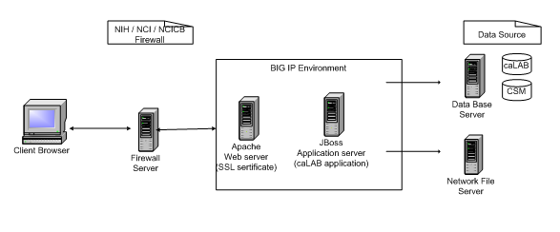
Figure 2-2: Deployment View
In this environment, the client browser instantiates an https request with login information and the request after authenticated reaches the Apache server for SSL certificate validation. The Apache server then delegates the request to the application server JBoss4.x. The application delegates an operation to a database or network file system based on the request.
At the ABCC, caLAB is deployed in a 2-tier environment with a staging and production server. The NCICB Administrators are responsible for maintaining user accounts, groups, and roles with guidance from the NCICB development team.

Components

Domain MODEL
At the core of the caLAB application are 1.) caLAB objects and 2.) Business Logic objects and respective relationships they share. The caLAB objects represent the data level laboratory objects (e.g., organization, assay, sample etc.) that are managed by the caCORE SDK to represent labs, the assays they run, and the samples they manage. The caLAB domain objects are designed to be extendable, allowing for capturing of assay data specific for a particular lab (e.g. nanoparticle assays and characterizations). Each model may share several common objects that in the context of a specific model type but, may have different associations. For this reason, this design captures the known caLAB object designs in separate UML diagrams with a diagram to render their high-level associations. These domain/business objects are implemented as Plain Old Java Objects (POJOs).
The caLAB system references the caCORE Software Development Kit (SDK). The caCORE SDK is a set of tools that can be used by an intermediate Java developer to create a 'caCORE-like' system. Such systems are constructed using certain design principles:
- UML Modeling
- N-tier architecture with open APIs
- Controlled vocabularies
- Registered metadata
A system built along these lines is said to be 'semantically integrated', that is, there exists runtime metadata that describes every class and class attribute in the API. The SDK consists of three components. The Semantic Connector assists in the annotation of the UML with appropriate controlled vocabulary terms. The UML Loader registers the annotated model in the caDSR, a metadata repository, and the Code Generator creates the software system in Java.
The sub-sections that follow provide details of the base caLAB object model (calab-om) and model extensions specific to nanoparticle assays (nano-om).

Base caLAB Object Model (calab-om)

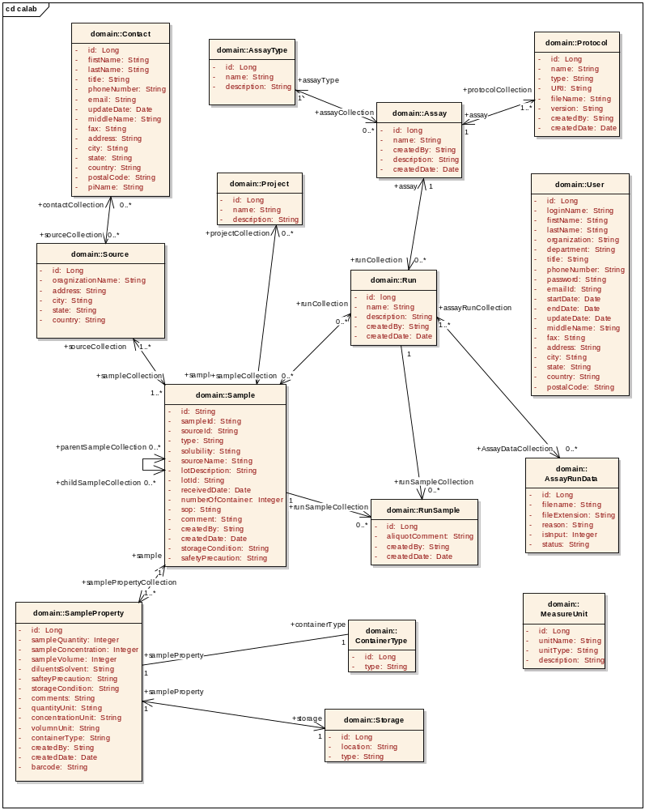
Figure 3-1: Base caLAB Object Model (calab-om)

Nanoparticle Object Model (nano-om)
The nano-om model focuses on developing a standard representation of nanoparticles and the outcome (characterizations) of assays applied to these nanoparticles. The model will be a caBIG annotated object model (nano-om) defining concepts for each object and attribute which are maintained in the NCI’s Enterprise Vocabulary Services (EVS). These concepts form the basis of a standard ontological hierarchy of terminology applicable to the use of nanotechnology in medicine.

The nano-OM is composed of the following high-level packages:

- Particle – Defines the basic classification of a nanoparticle as a type of sample. Classifications range from organic, to inorganic, to complex or hybrid particles.
- Function – Represents the function of a nanoparticle as a targeting, therapeutic, or diagnostic agent. Identifies particle agents (e.g. antibody, peptide) and Agent Targets (antigens, receptors) and the associated linkage bond.
- Characterization - Base package which describes the conditions in which the particle was characterized, the instrument and protocol leveraged, and the graphs and charts that provide insight into the complexities of the characterization.

The Characterization package is further sectioned into discrete packages modeled after the NCL assay cascade:

- Physical Characterizations – Provides information about the nanoscale entities such as particle type (e.g. dendrimer, fullerene, complex) composition, structure, and other material properties.
- In Vitro Characterizations – Identifies the cellular toxicity (cytotoxicity), immunotoxicity, and metabolic stability of the particle. [Metabolic Stability not implemented in caLAB 1.0].
- In Vivo Characterizations – Describes general particle toxicity properties and pharmacokinetics. Provides generalized understanding of particle efficacy. [Not implemented in caLAB 1.0].

The subsections that follow illustrate the objects and attributes associated with each package.

Particle Package
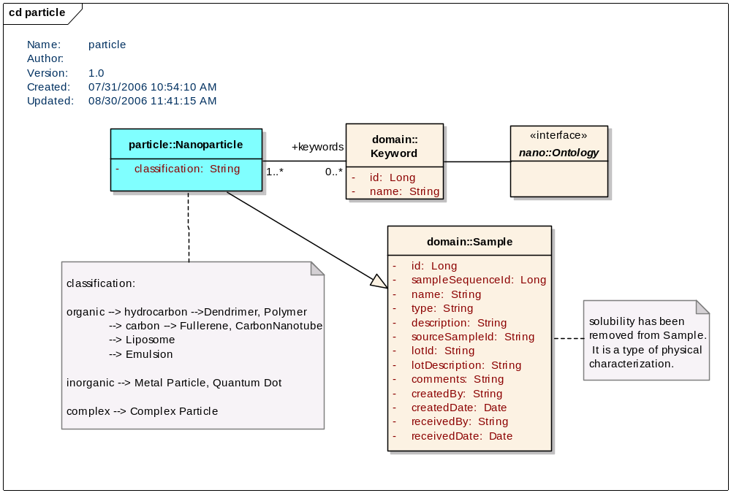
Figure 3-2: Particle Package (nano-om)

Function Package

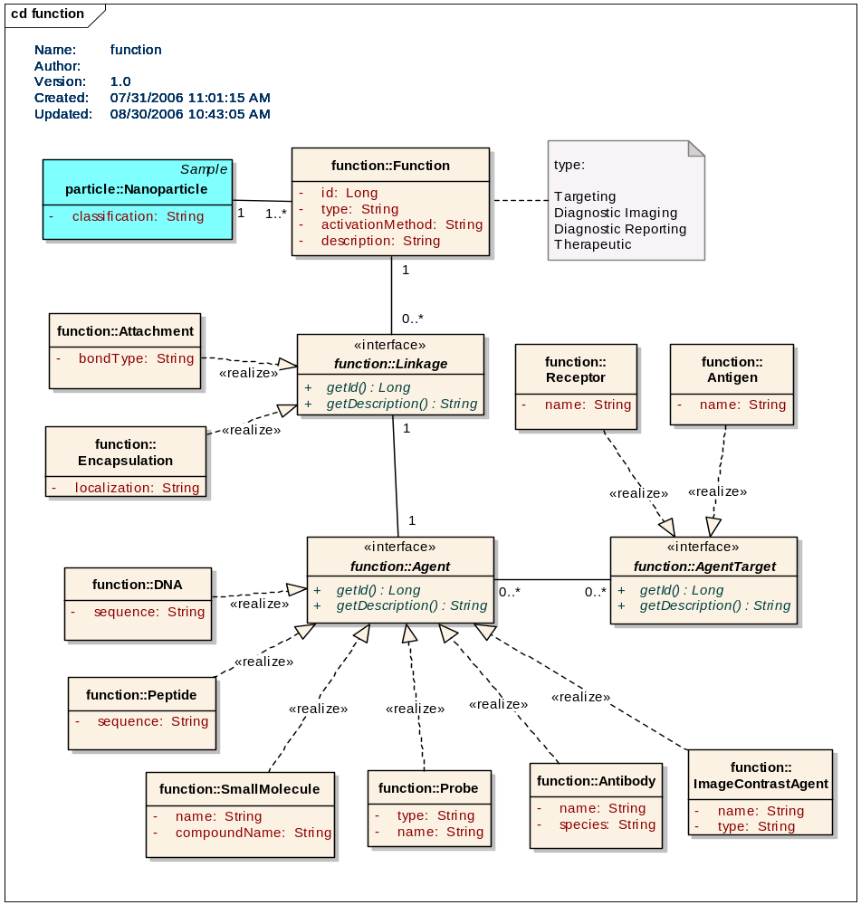
Figure 3-3: Function Package (nano-om)

Characterization Packages

Base Characterization Package
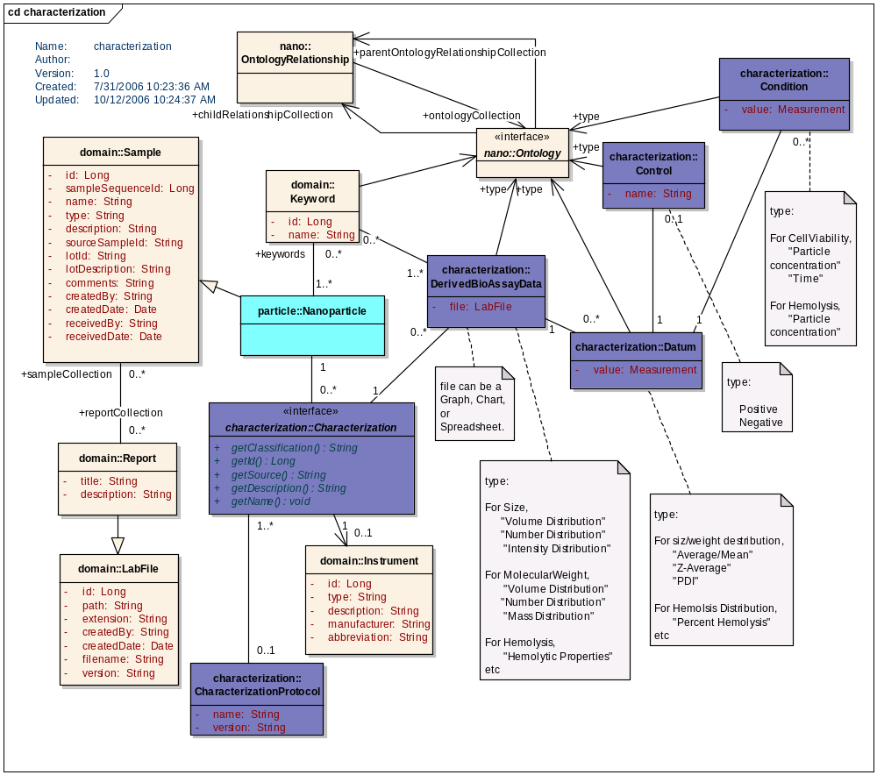
Figure 3-4: Base Characterization Package (nano-om)

Physical Characterization
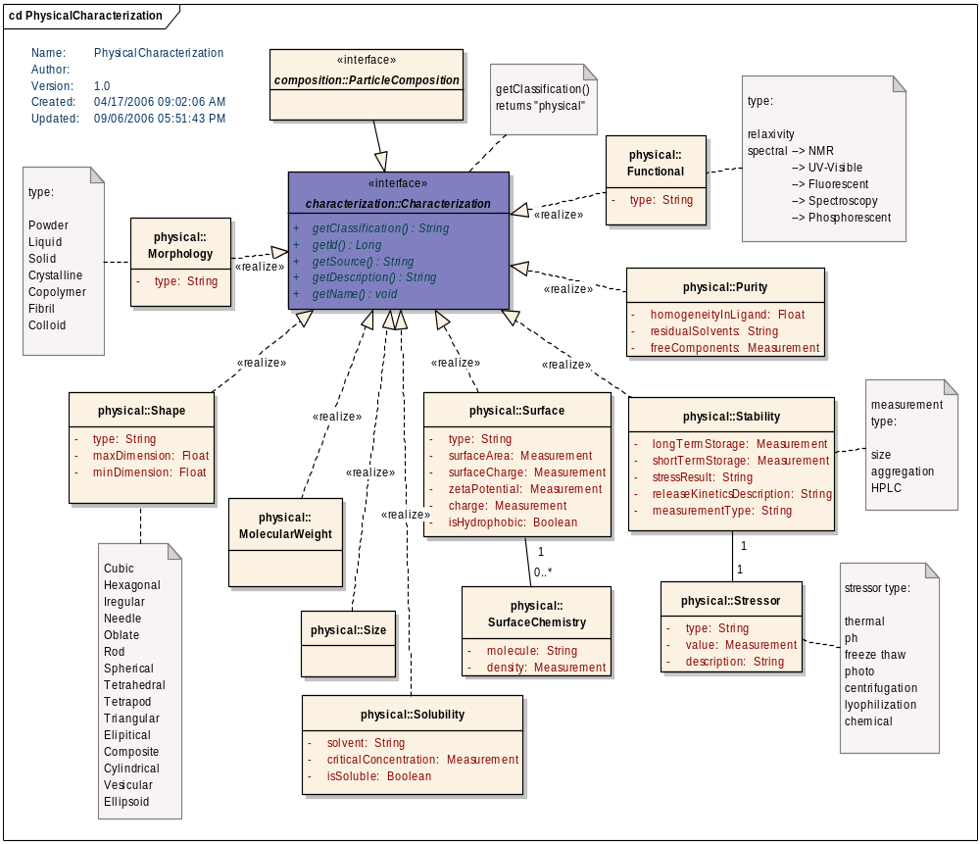
Figure 3-5: Physical Characterization Package (nano-om)

Physical Composition Package
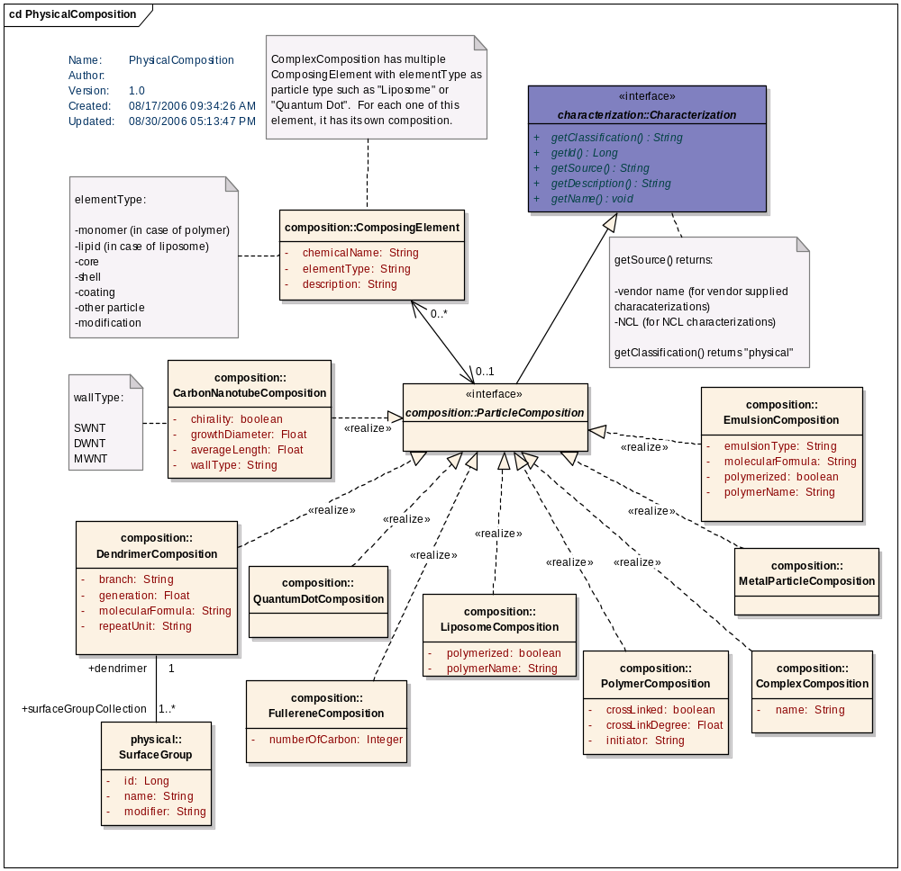
Figure 3-6: Physical Composition Package (nano-om)

In Vitro Characterization Package
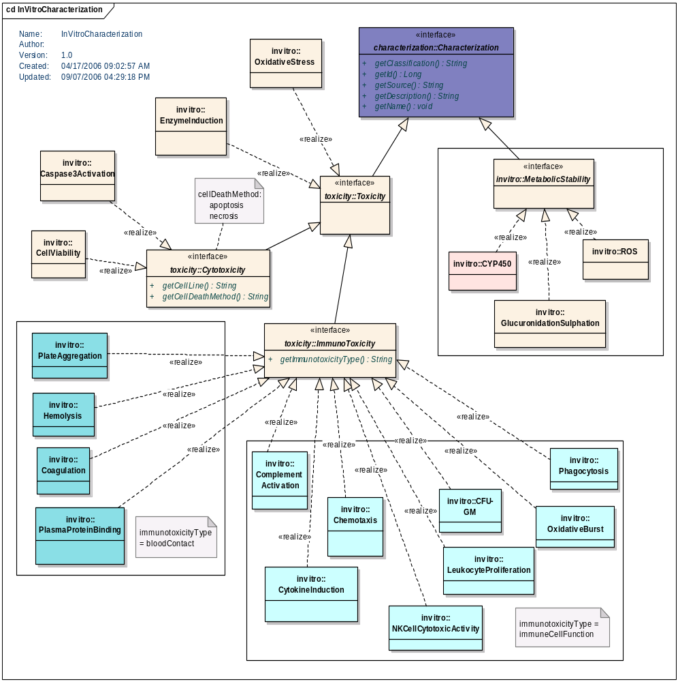
Figure 3-7: In Vitro Characterization Package (nano-om)

In Vivo Characterization Package
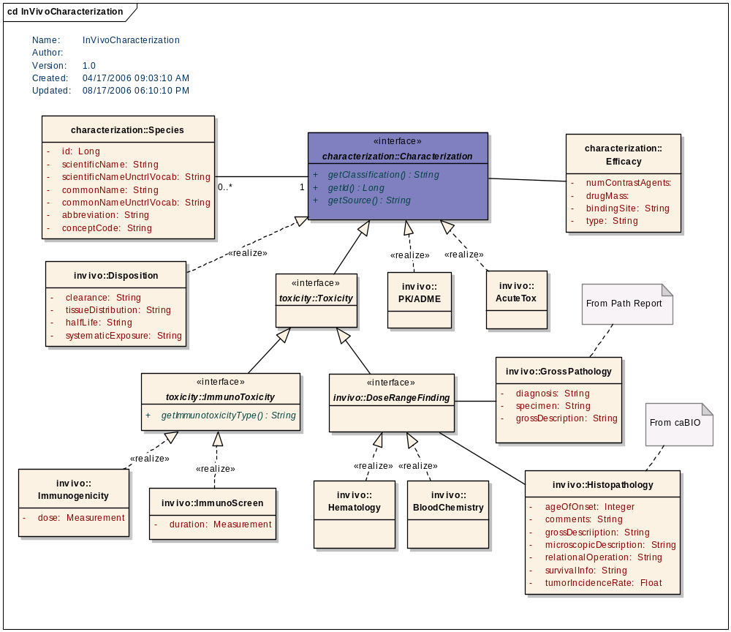
Figure 3-8: In Vivo Characterization Package (nano-om)

daTA MODEL
The caLAB 1.0 Data Model supports the caLAB object model (calab-om) and extended nanoparticle model (nano-om). The subsections that follow illustrate the data model.

caLAB Data Model (calab-om)
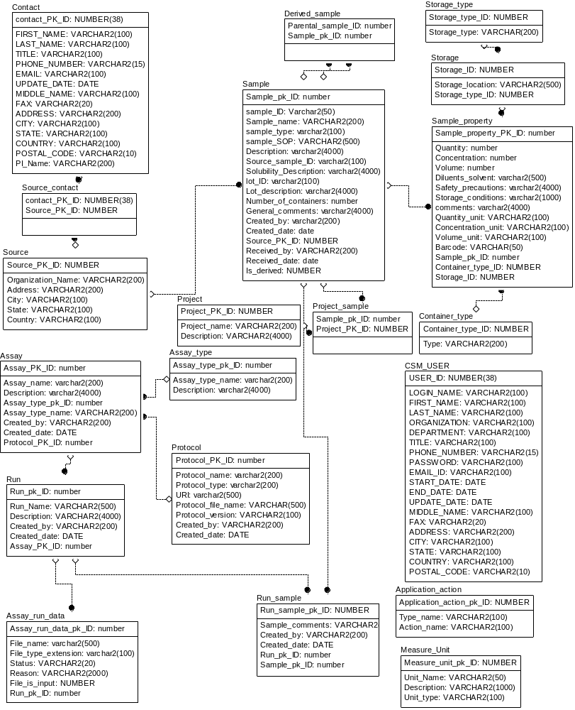
Figure 3-9: caLAB Data Model (calab-om)

Table Name | Description
SOURCE | Contains the organization information that submit the sample to the lab
CONTACT | Contains the individual information from an organization who is the POC for submitting the sample
SOURCE_CONTACT | Link table between SOURCE and CONTACT
ASSAY_TYPE | Contains different type of Assay that is performed in the lab
ASSAY | Contain assay information for different assay type, and the audit information
PROTOCOL | Contains URI for the protocol file, and the relationship with assay
RUN | Contains activity run for each assay
ASSAY_RUN_DATA | Contains the input and output file info for each individual run
RUN_SAMPLE | Contain the relationship between RUN and SAMPLE, and also the comments for the sample used in particular run
SAMPLE | Contains original submitted sample as well as the final aliquot information
SAMPLE_PROPERTY | Contains sample information in certain container
DERIVED_SAMPLE | Contains the relationship between samples. One sample can be created from multiple other samples.
STORAGE_TYPE | Contains different type of storage in the lab facility, such as room, freezer, rack, etc
STORAGE | Contains individual storage location in the facility
CONTAINER_TYPE | Contains different container in the lab, such as tube, vial, plate, etc.
MEASURE_UNIT | Contains quantity, concentration, volume’s unit
CSM_USER | Contains lab user information. It is also a required table for Common Security Module

Table 3-1: caLAB Data Model (calab-om)

Nanoparticle Data Model (nano-om)
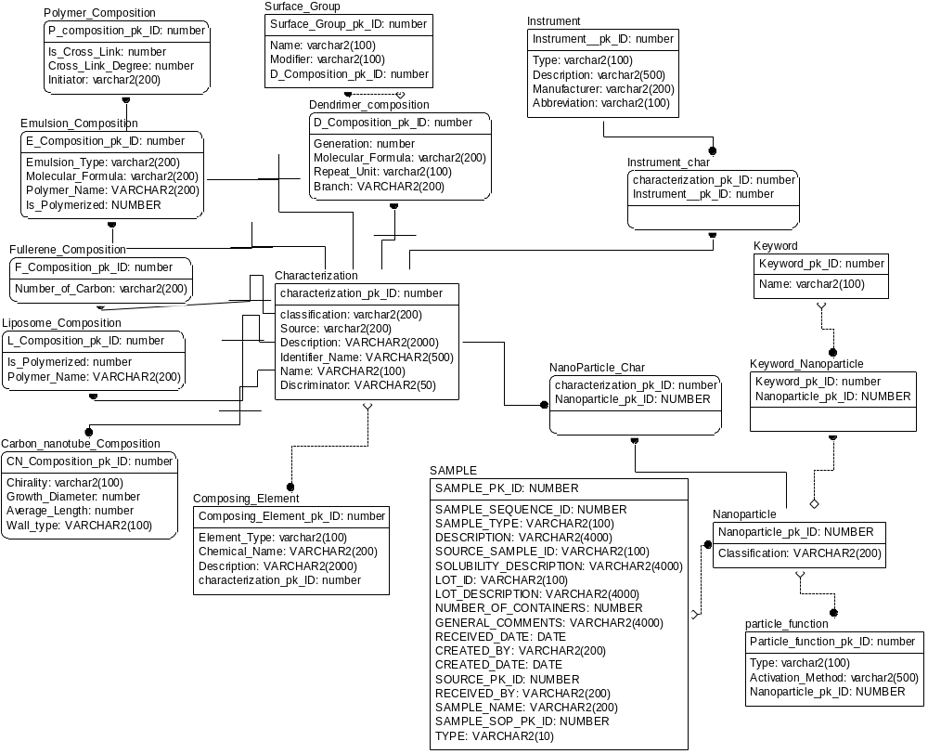
Figure 3-10: caLAB 1.0 Data Model

Table Name | Description
NANOPARTICLE | Contains the Nanoparticle information that are generated when sample is submitted
KEYWORD | Contains the particle keywords, and characterization table keywords
INSTRUMENT | Contains the instrument type that can be used to indicate where the characterization data from
PARTICLE_FUNCTION | Contains the Nanoparticle function data
KEYWORD_NANOPARTICLE | Linkage table between Keyword and Nanoparticle
INSTRUMENT_CHAR | Linkage table between instrument and Characterization
NANOPARTICLE_CHAR | Linkage table between Nanoparticle and Characterization
LIPOSOME_COMPOSITION | Contains additional attribute for Liposome composition
FULLERENE_COMPOSITION | Contains additional attribute for Fullerene composition
EMULSION_COMPOSITION | Contains additional attribute for Emulsion composition
CARBON_NANOTUBE_COMPOSITION | Contains additional attribute for Carbon Nanotube composition
POLYMER_COMPOSITION | Contains additional attribute for Polymer composition
COMPOSING_ELEMENT | Contains Core, Shell, Coating, Modification information
SURFACE_GROUP | Contains Dendrimer surface group information

Table 3-2: Nanoparticle Data Model (nano-om)

Presentation layer
The diagram below illustrates an example interaction between the major classes in the presentation framework. Please note that the sequence is drawn from a specification perspective to provide an overview of the normal sequence between these important classes.

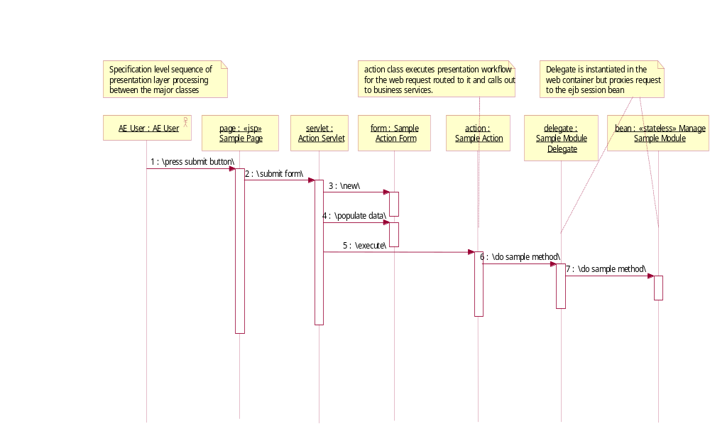
Figure 3-11: Presentation Layer Sequence Diagram

FILE STRUCTURE
Files (reports, assay results) are stored on the network file system based on a pre-defined directory structure and file naming conventions are employed to avoid overwriting files due to duplicate files names. Below are the directory structures in which the files reside:
Reports Directory: $ROOT/reports/$FILE_NAME
Where, $FILE_NAME = $ORGINAL_FILENAME_$TIMESTAMP(till mil sec).$EXT
When a user submits a report, a new data entry is created in the database. Since a report may contain information on multiple particles, when submitting a report, the user must select the particle(s) that the report is associated with as well as entering the title, description, comments, keywords, and report visibility.
For assay results (DerivedBioAssayData) file upload, an additional layer of file structure is needed:
File Directory:
$ROOT/particles/$PARTICLE_NAME/$CHARACTERIZATION_NAME/$FILE_NAME
Where,
$PARTICLE_NAME = particle id (e.g. NCL-3)
$CHARACTERIZATION_NAME = characterization (e.g. size)
$FILE_NAME = $ORGINAL_FILENAME_$TIMESTAMP(till mil sec).$EXT
The DerivedBioAssayData file path will be updated everytime a new file is uploaded.

Common Security Module
caLAB is designed as a secure application that integrates with the NCICB authentication infrastructure. caLAB 1.0 extends provides authentication and authorization services using a relational Database Management System (RDBMS) implementation.

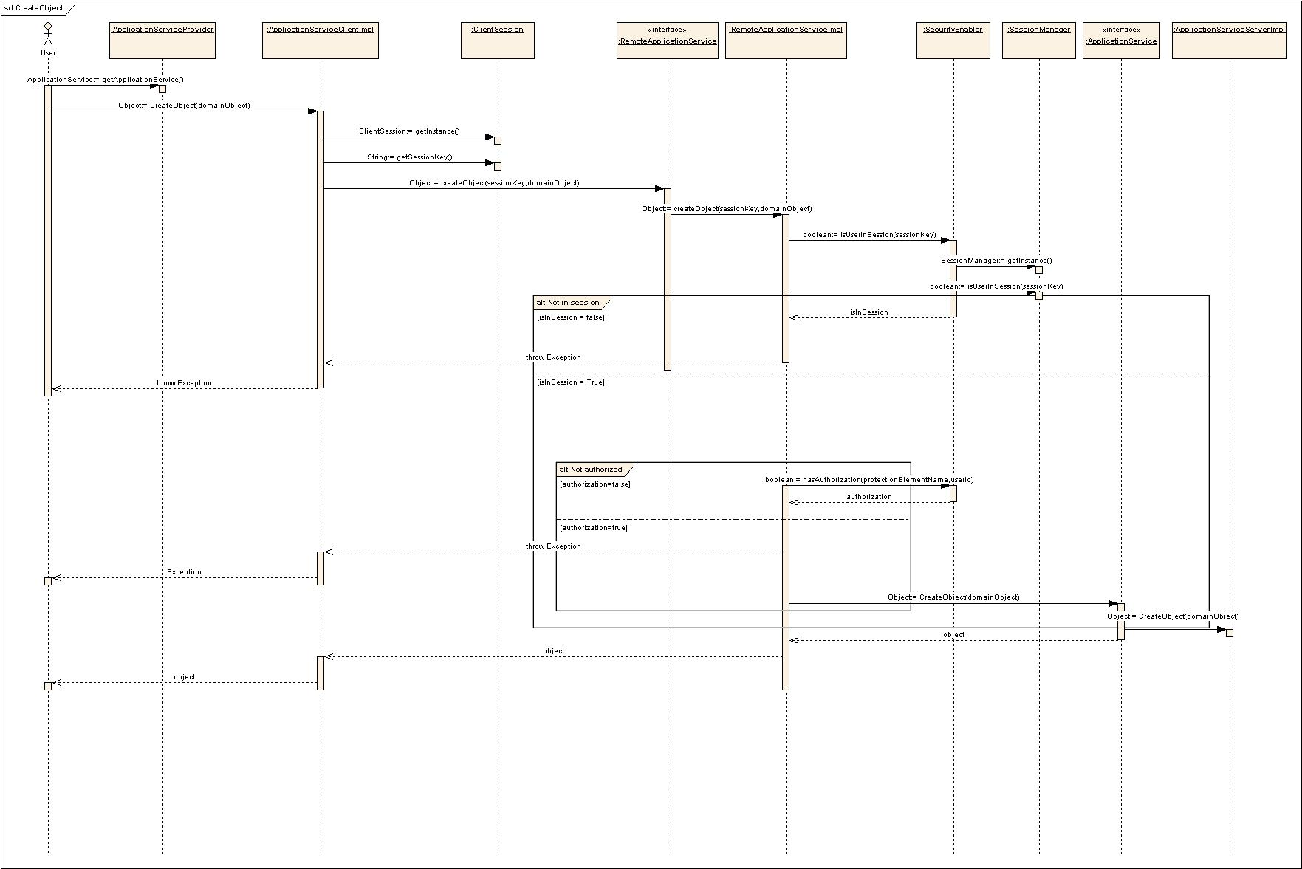
Figure 3-12: CSM Sequence Diagram
Using the authorization security service application, caLAB provides an application security client that addresses caLAB application requirements. caLAB logs into the common security application on startup and retrieves the application’s role and privilege, which are stored application-wide. User-specific information is retrieved on each user’s login. Programmatic security is performed locally using the retrieved objects.
In the implementation of the security module, the following apply:
  - User roles and authorizations are protocol-based
  - Declarative security is used for access
  - For protocol-specific security checks, programmatic security is executed. User id, roles and privilege information are checked by protocol to determine access.
  - JSP custom tags are used to check for roles and/or privileges in the web application. Tags include or exclude content based on the results of security checks.

Appendix A – acronym List
Acronym | Description
ABCC | Advanced Biomedical Computing Center
caCORE | Cancer Common Ontological Representation Environment
caLAB | Cancer Laboratory Analysis Bench
CCNE | Cancer Center of Nanotechnology Excellence
CSM | Common Security Module
DAO | Data Access Object
DTO | Data Transfer Object
JSP | Java Server Page
JSTL | Java Server Page Tab Library
NCICB | National Cancer Institute Center for Bioinformatics
NCL | Nanotechnology Characterization Laboratory
RDBMS | Relational Database Management System
SDK | Software Development Toolkit
SSL | Secure Socket Layer
SWDD | Software Design Description
UML | Unified Modeling Language
UPT | User Provisioning Toolkit

